**Final Project**

**Tinashe Lance Chaduka**

**University of Maryland University College**

**DBST 651-5121**

**SPRING 2019**

**TA Zibo Song**

**Statement of Work (SOW)**

Tinashe Lance Chaduka DBST651, 2019

**Overview/ Executive Summary:**

I am going to be creating a database for my daughter’s daycares. As a result of adopting to my database the owner of the daycare can realize many benefits such as: Less administrative work, Improved Communication with parents, Advanced and trackable meals and nutrition planning, and Great staff coordination.

**Purpose and Objective:**

Child care profession can be very busy, and difficult to not only keep up with the children, but stay on top of administrative, scheduling and financial duties, as well. The database will enable a daycare owner or the teacher to enter and store daily activities for each enrolled child. It will be including Attendance, Billing, Activities, Meals, Child’s information etc. The purpose of the database is to provide a detailed assessments and observations of each child to the parents. It will also support the teachers taking care of the children by keep a record of all daily activities.

**Project Scope / Database Goals, Expectations, and Deliverables:**

The database will be capable of the following

* Admissions and scheduling – schedule classes for both teachers and children as well as enrollments and registration.
* Billing and payments – Allow users to perform billing and invoicing, track account balances and past due payments, create and print/email payment reports and statements. Multiple payment methods online, in-person, including cash, check, money order, official check and credit/debit cards.
* Reporting – it will generate reports and provides alerts for children’s birthdays. Creates reports on revenues summaries, class statistics such as class type and size, attendance, and financial transactions.
* Employee management/ time and attendance – staff check-in and out, manages employee hours and regular employee information.
* Communication- allow uses to keep parents informed about their child’s activities and progresses.
* Meal management – track meals and nutrition.
* Activities – enter lesson plans or activities done by the child.

**Database Benefits:**

* Streamlined Administrative work: The database will help reduce administrative work by automating the tasks such as online registration to allow employees to focus on the children and give them undivided attention.
* Improved communication with parents: Parents would not have to worry or inquire about their children. The owner or employees will be able to send parents notifications about their child’s daily activities and progresses.
* Meal and Nutrition tracking: Owner or employee will be able to enter and track the number of meals given to each child. That is breakfast, lunch and snacks throughout the day.
* Staff coordination: Instead of using paper-based recording owner or employees will be able to digitally record activities. The system will be accessible to multiple users in different locations. It will allow the owner or employees to update any necessary documentation.

**Diagram Tool:**

ER Assistant

**Database:**

Oracle 11g, using Virtual Desktop Applications (VDA)

**Hardware and Software:**

UMUC (VDA) Intel(R) Xeon(R). Operating system is Linux.

**DDL and DML:**

SQL (Structured Query Language) will be used for the DDL and DML. For my DDL scripts, I will use SQL to translate the information captured in my ER diagram (created in ER Assistant) into database table creation scripts. For my DML scripts, I will use SQL to insert rows of data into my database tables.

**Timeline:**

|  |  |
| --- | --- |
| **Task** | **Due date** |
| Project Part # 1: Statement of Work (SOW) | 3/5/2019 |
| Project Part # 2: Requirements Definition Document and Entity Relationship Diagram (ERD) | 3/19/2019 |
| Project Part # 3: Data Definition Language (DDL) SQL Script | 4/8/2019 |
| Project Part # 4: Data Manipulation Language (DML), 20 Queries, and Consolidated Final Report) | 4/22/2019 |

**Requirements Definition Document and Entity Relationship Diagram (ERD)**

1. **Business Rules**

* An Employee may teach zero or many children; a child must be taught by one and only one Employee
* A child may enroll zero or many times; an enrollment must be enrolled by one and only one child
* A child may eat a meal zero or many times; a meal must be eaten by one and only one child
* A child may have a child report zero or many times; a child report must be done for one and only one child
* A child may participate in an activity zero or many times; an activity must be done by one and only one child
* A Parent may enroll zero or many children; a child must be enrolled by one and only one parent
* A Parent may be billed zero or many times; a Tuition must be billed to one and only one Parent
* An Employee may work zero or five days per scheduled week; a day’s work can only be entered for one and only one employee.
* An Employee may direct zero or many activities; an activity can only be directed by one and only one employee
* An activity may be signed up zero or many times; an enrollment can only be assigned to one and only one activity
* A report may be done zero or many times; an employee can only do one and only one report per child.

1. **Entity and Attribute Description**

* **Employee Entity** is a teacher employed at the daycare
  + **Employee_ID** is an attribute and it is the primary key for Employee Entity the data type is NUMERICAL
  + **Firstname** is an attribute employee’s first name the data type is VARCHAR (50)
  + **Lastname** is an attribute employee’s first name the data type is VARCHAR (50)
  + **Gender** is an attribute employee’s gender the data type is VARCHAR (6)
  + **Date_Worked** is an attribute for when the employee worked the data type is DATE
  + **Address** is an attribute employee’s physical address the data type is VARCHAR (50)
  + **Birth_Date** is an attribute for when the employee was born the data type is DATE

* **Child Entity** is the child at the daycare
  + **Child_ID** is an attribute and it is the primary key for Child Entity the data type is NUMERICAL
  + **Lastname** is an attribute child’s first name the data type is VARCHAR (50)
  + **Firstname** is an attribute child’s first name the data type is VARCHAR (50)
  + **Address** is an attribute for child’s physical address the data type is VARCHAR (50)
  + **Gende**r is an attribute for Child’s gender the data type is INT – aligned with Enum in code (1=Male, 2 =Female, and 3 Does not want disclose)
* **Enrollment Entity** is the enrollment information
  + **Enrollment_ID** is an attribute and Primary Key for Enrollment the data type is NUMERICAL
  + **Child_ID** is an attribute and it is the Foreign key for Enrollment Entity the data type is NUMERICAL
  + **Activity_ID** is an attribute and it is the Foreign key for Enrollment Entity the data type is NUMERICAL
  + **Date_Enrolled** is an attribute for when the child was enrolled the data type is DATE
  + **Term** is an attribute for which semester is the child enrolled in and the data type is CHAR (6) Spring, Summer, and Fall
* **Tuition Entity** is the amount billed to the parent per child
  + **Tuition_ID** is an attribute and Primary Key for tuition the data type is NUMERICAL
  + **Parent_ID** is an attribute and it is the Foreign Key for Tuition Entity data type is NUMERICAL
  + **TotalBill** is an attribute for total amount billed to a parent data type is DECIMAL
  + **BillingDate** is an attribute for when the parent was billed data type is DATE
  + **Payment_Method** is an attribute for how the parent paid the bill data type is CHAR (15) Cash, Credit card, Check, Auto-pay, Direct Deposit, and Prepaid
* **Report Entity** is the child’s assessment report
  + **Report_ID** is an attribute and Primary Key for Report data type is NUMERICAL
  + **Date_Reported** is an attribute to show when the report was completed for the Child data type is DATE
  + **Employee_ID** is an attribute and Foreign Key to identify which employee completed the report for ChildReport data type is NUMERICAL
  + **Child_ID** is an attribute and Foreign Key to identify which Child was the report done for ChildReport Entity data type is NUMERICAL
  + **Vaccination** in an attribute to show what immunizations a child received for ChildReport entity data type is VARCHAR (30)
* **Meal Entity** to show what meals did the Child eat for the day attended
  + **Meal_ID** is an attribute and Primary Key for Meal Entity data type is NUMERICAL
  + **Meal­_Date** an attribute to show when the meal was given to the child data type is DATE
  + **Meal_Name** an attribute to identify what meals was given to a child data type CHAR (5) Break, Lunch or Snack
  + **Meal_Time** is anattribute to record what time was the meal given to the child data type TIME
  + **Food_Type** is an attribute to identify what kind of food was given to the child VARCHAR (20)
* **Activity Entity** to identify what activities did the child done for the day
  + **Activity_ID** is an attribute and Primary Key for Activity Entity data type is NUMERICAL
  + **Activity_Name** is an attribute to identify the name of the activity done by the child data type is VARCHAR (20)
  + **Employee_ID** is an attribute and Foreign Key to show wat report is it linked to for Activity entity data type is NUMERICAL
  + **Activity_Date** is an attribute to identify what date the child completed the activity data type is DATE
  + **Activity_Time** is an attribute to show what time the activity was completed data type is TIME
* **Employee­Schedule** Entity for employee’s scheduled to work
  + **Schedule_ID** is an attribute and Primary Key to identify when employee should report to work for EmployeeSchedule entity data type is NUMERICAL
  + **Date_Scheduled** attribute to identify when employee should be working data type is DATE
  + **Name** is an attribute to identify the name of the schedule for EmployeeSchedule entity data type CHAR (10)
  + **Start_Time** is an attribute to identify the time when an employee started working for the EmployeeSchedule entity data type is TIME
  + **End_Time** is an attribute to identify the time when an employee ended a day’s work data type is TIME
* **Parent Entity** for a parent’s information with an enrolled Child
  + **Parent_ID** is an attribute and Primary Key to identify a parent for Parent entity data type is NUMERICAL
  + **FirstName** is an attribute to identify a parent’s first name for the Parent entity data type VARCHAR (50)
  + **LastName** is an attribute to identify a parent’s last name for the Parent entity data type VARCHAR (50)
  + **Address** is an attribute for parent’s physical address for Parent entity the data type is VARCHAR (50)
  + **Tuition_ID** is an attribute and Foreign Key to identify what tuition is the parent being billed for Parent entity data type is NUMERICAL
  + **Child_ID** is an attribute and Foreign Key to identify which child the parent was billed for Child entity data type is NUMERICAL

1. **Relationship and Cardinality Description**

For each relationship, describe the relationship itself and describe the relationship cardinality/minimum cardinality using the description format in the Project Learning Demonstration. To meet this requirement, you need only to describe the relationship that connects two entities one time.

|  |  |  |
| --- | --- | --- |
| **Relationship** | **Cardinality** | |
| Employee + Child | 1-M | |
| Child + Enrollment | 1-M | |
| Meal +Child | M-1 | |
| Report +Child | 1-M | |
| Child +Activity | 1-1 | |
| Parent + Tuition | 1-M | |
| EmployeeSchedule + Employee | M-1 | |
| Parent + Child | 1-M | |
| Activity +Employee | M-1 | |
| Enrollment + Activity | M-1 | |
| Employee + Report | | 1-M | |

1. **Assumptions and Special Considerations**

* The database will allow as many users to join the daycare website. Each user is identified by key Parent_ID or Employee_ID
* Parent (single user) can create only one account and becomes a member.
* Both Emplyee or Parent (member) can upload files to the report entity. Employee has special privilege to delete, and update report
* The Daycare has multiple employee to write a report. And each employee is identified with an Employe_ID
* The daycare will have only single manager.
* Parent can write to the daycare manager.

**DataDefinition Language (DDL) SQL Script**

1. **Drop Statements for All Objects as needed (5 points)**

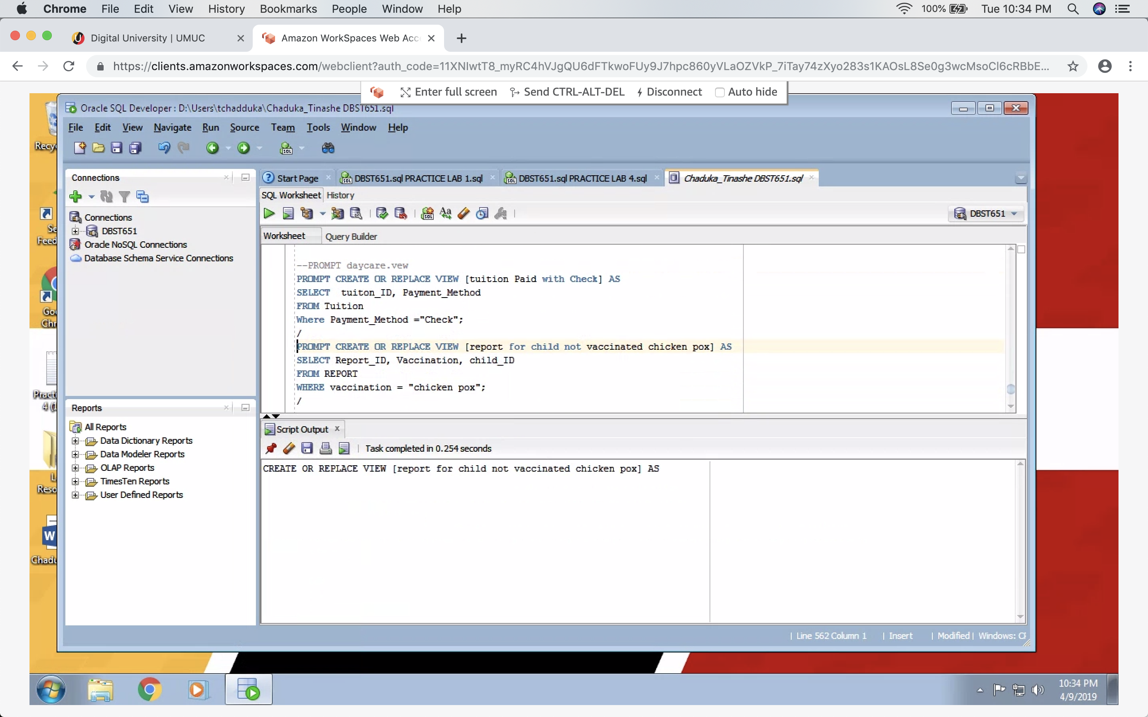

1. **Create/Alter Statements for All Tables and Constraints (30 points)**

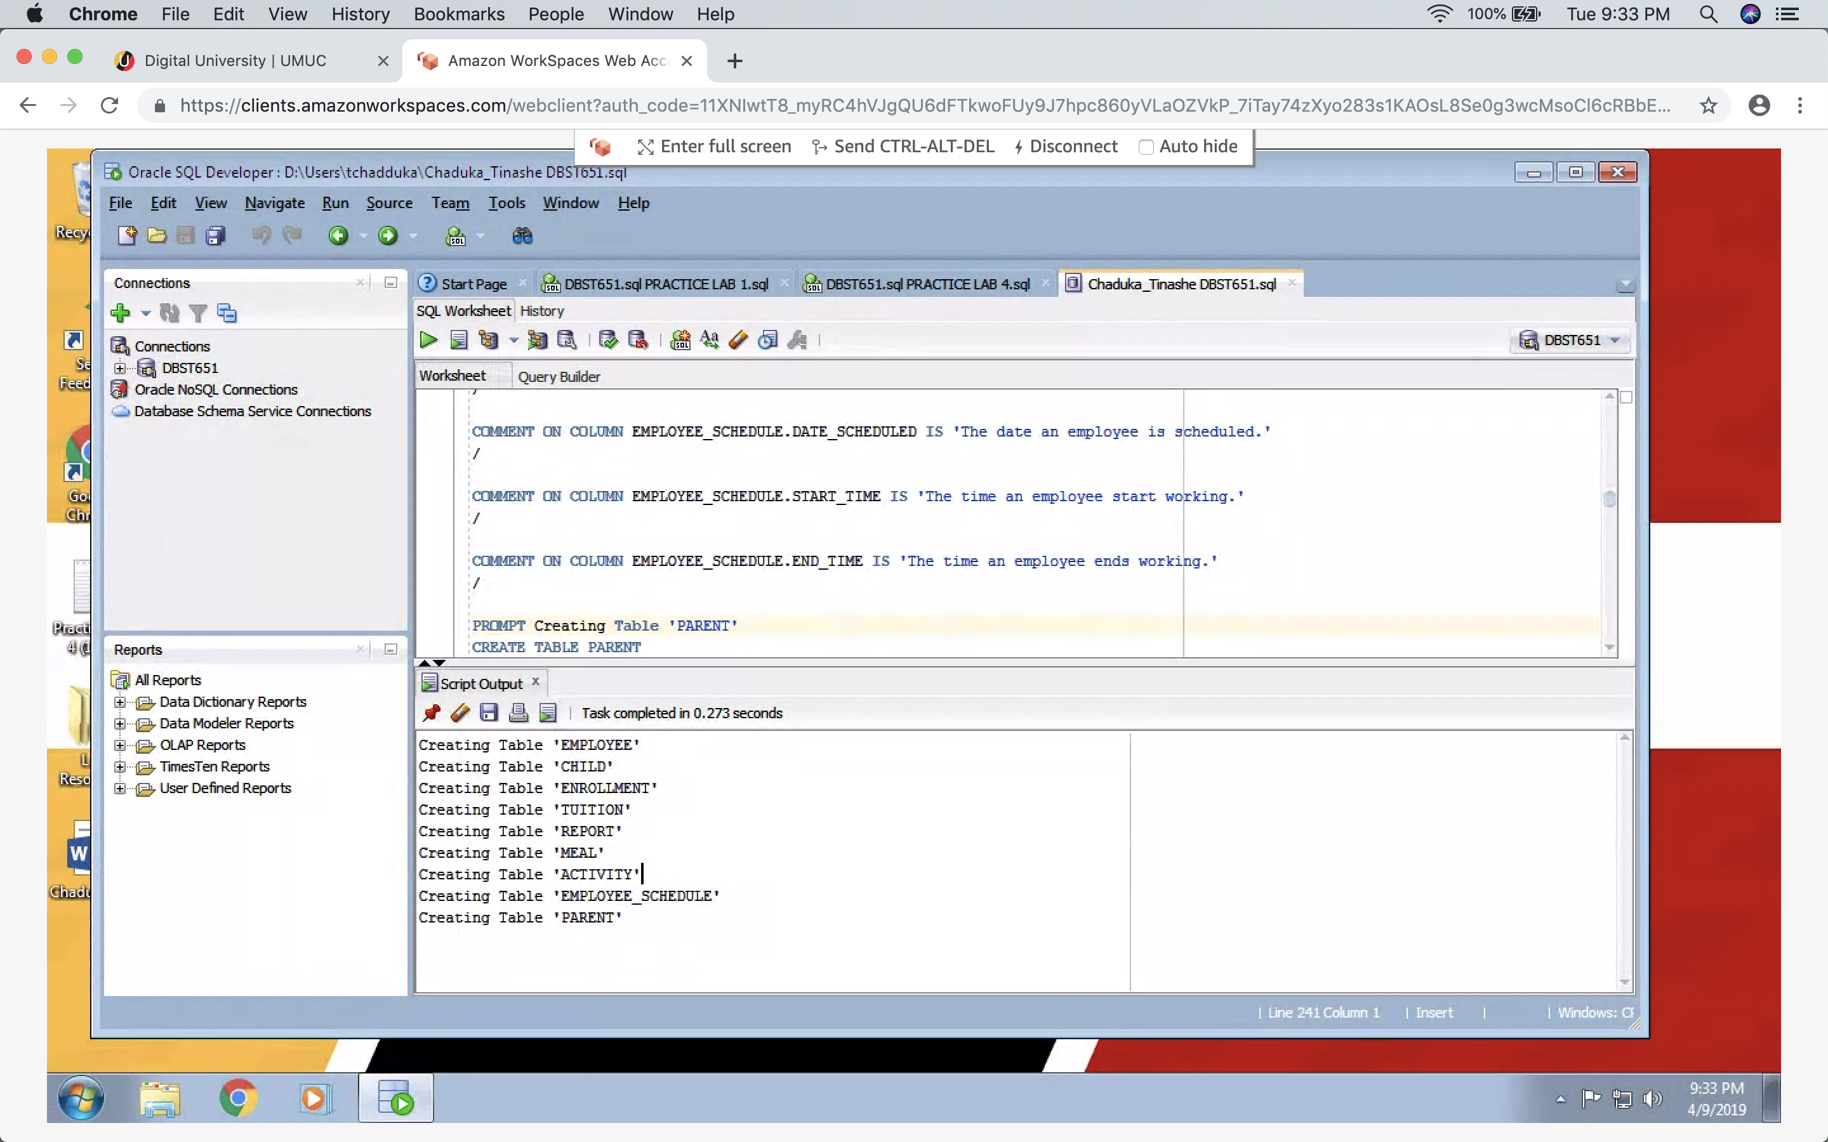

1. **Create Indexes for Natural, Foreign Key, and Frequently Queried Columns (10 points)**

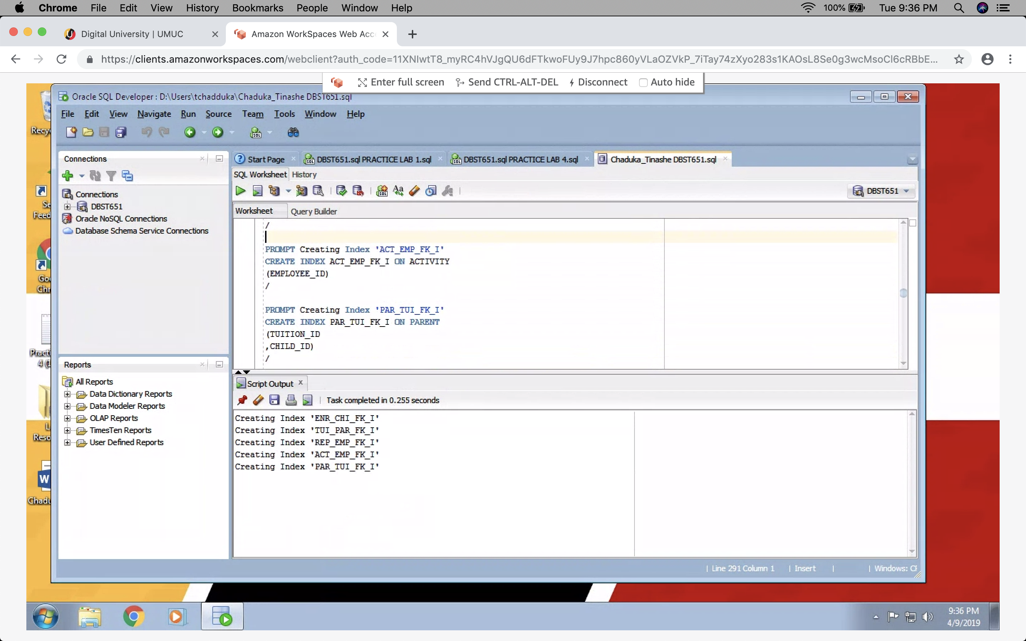

1. **Create a Minimum of Two Views (10 points)**

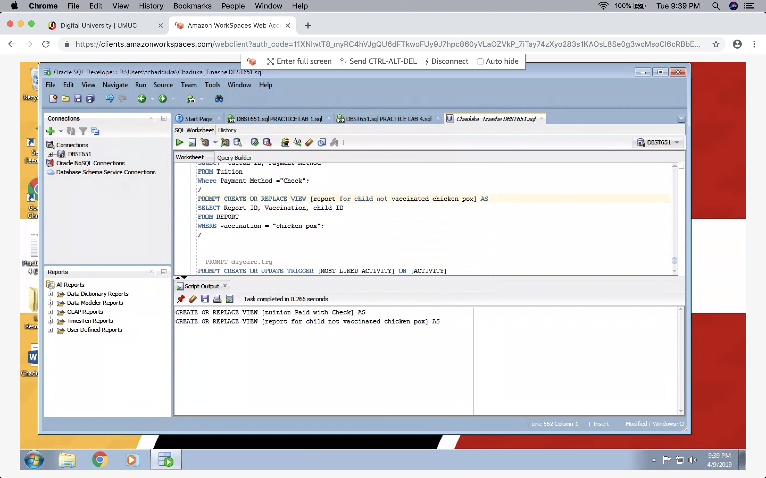

1. **Create a Minimum of Two Sequences (10 points)**

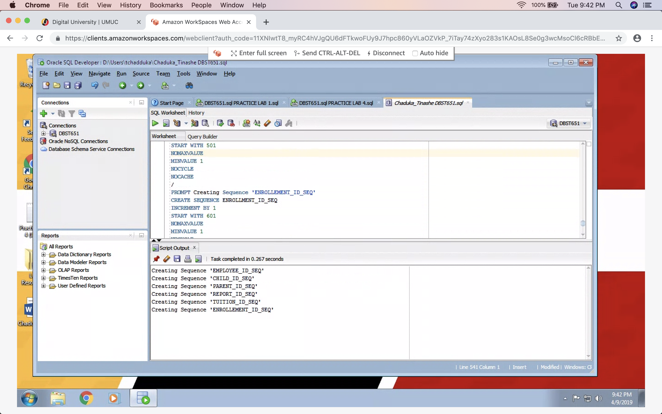

1. **Create a Minimum of Two Triggers (10 points)**

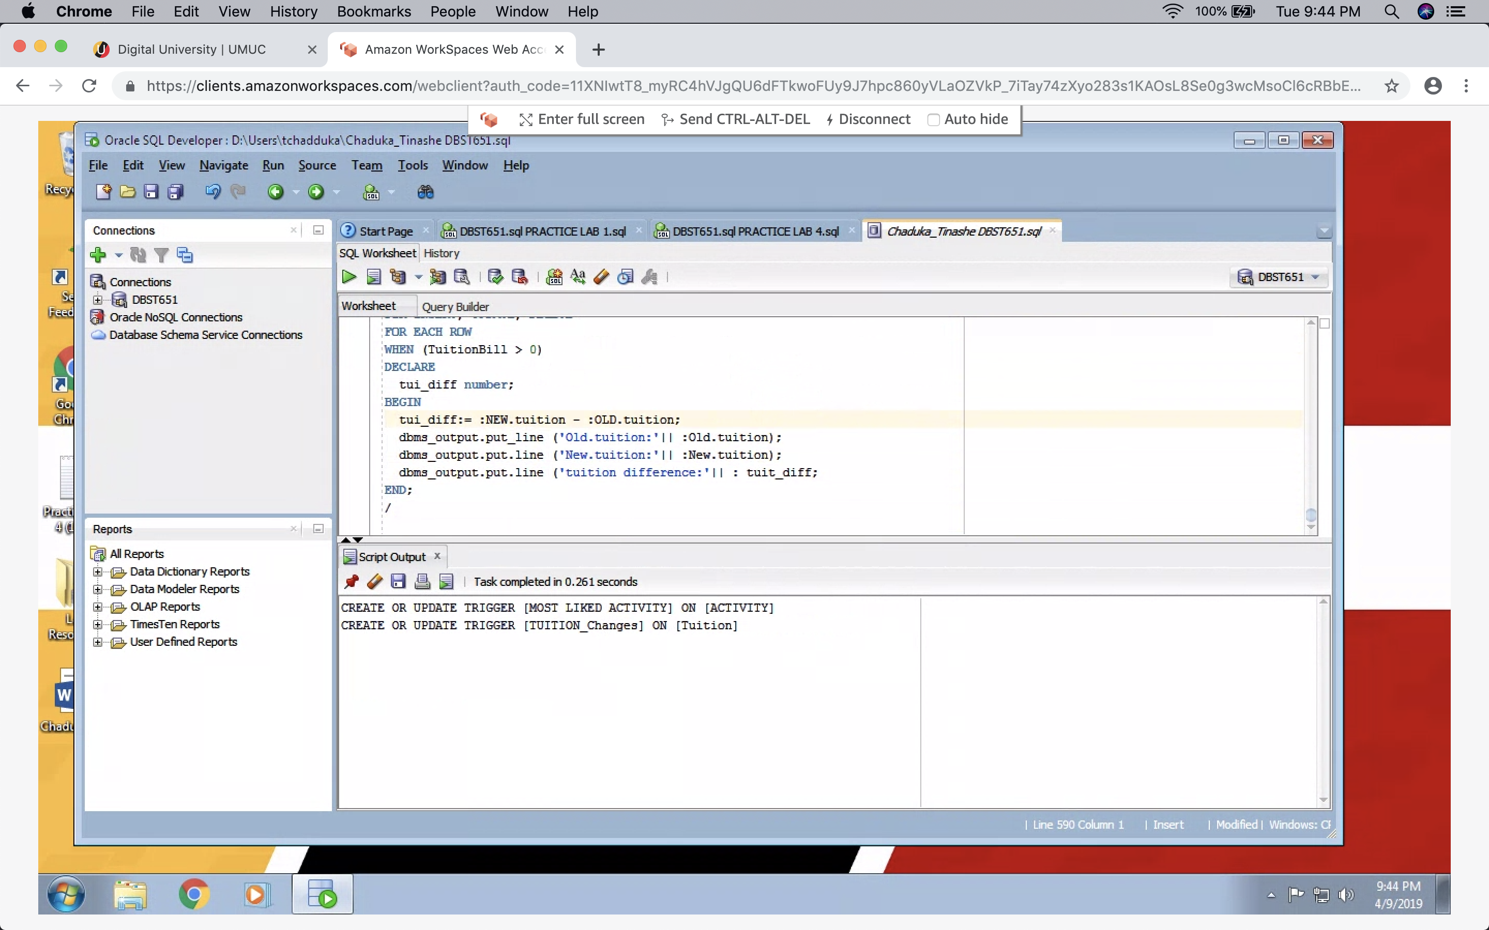

1. **Describe the Business Purpose of your Views and Triggers (5 points)**

* Most liked activity helps me to track which activity is liked most with the kids so we can make sure we include it at most times for the kids to have fun.
* Tuition changes trigger helps our daycare center to track our tuition changes for our sales department
* Tuition paid with checks view helps our accounts departments to monitor NSF check report and to make sure we have funds available before our accounts payable used the funds.
* Report for Child not vaccinated chicken pox helps us track un vaccinated child to make sure we have all children vaccinated.

1. **Database Catalog/Data Dictionary Queries (5 points)**

Demonstrate the successful creation of all aforementioned objects by querying the database catalog/data dictionary; see the Project Learning Demonstration for examples.

1. **Output Report (5 points)**

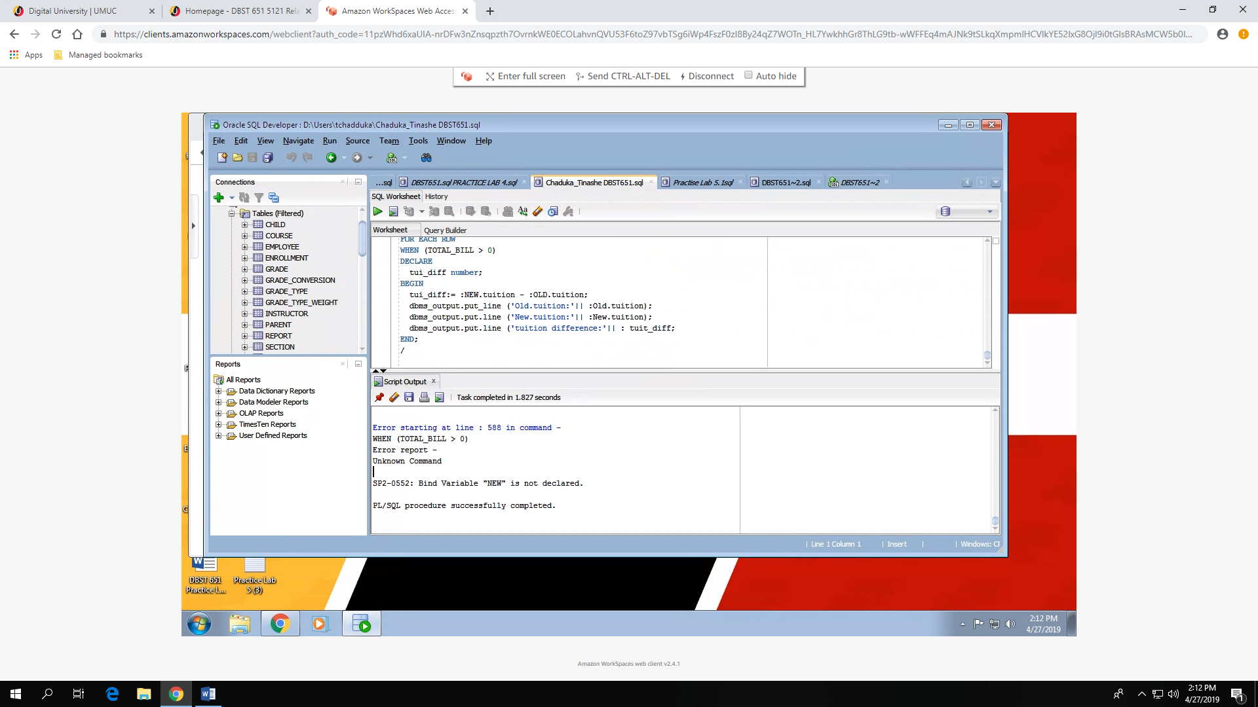

1. **Executable, Error-Free Script (10 points)**



**DML and Query Source Code Embedded (10 points)**

1. **Query 1: Select all columns and all rows from one table (5 points)**

SELECT * FROM CHILD;

1. **Query 2: Select five columns and all rows from one table (5 points)**

SELECT DISTINCT Report_ID, CHILD_ID, DATE_REPORTED, EMPLOYEE_ID, VACCINATION FROM REPORT ENTITY;

1. **Query 3: Select all columns from all rows from one view (5 points)**

SELECT * FROM TUITION.PAYMENT_METHOD WHERE TUITION = ‘Tuition paid with Check’;

1. **Query 4: Using a join on 2 tables, select all columns and all rows from the tables without the use of a Cartesian product (5 points)**

SELECT *FROM Child c INNER JOIN Parent p ON c.ID = d.child_ID;

1. **Query 5: Select and order data retrieved from one table (5 points)**

SELECT Food_Type FROM Meal ORDER BY Food_Type DESC;

1. **Query 6: Using a join on 3 tables, select 5 columns from the 3 tables. Use syntax that would limit the output to 10 rows (5 points)**

SELECT FIRST_NAME,LAST_NAME,CHILD_ID FROM CHILD WHERE

CHILD_ID IN (CHILD, PARENT, REPORT)ORDER BY CHILD_ID;

1. **Query 7: Select distinct rows using joins on 3 tables (5 points)**

SELECT * FROM CHILD, PARENT, REPORT WHERE CHILD.CHILD_ID=PARENT.CHILD_ID=REPORT.CHILD_ID;

1. **Query 8: Use GROUP BY and HAVING in a select statement using one or more tables (5 points)**

SELECT FOOD_TYPE FROM MEAL WHERE FOOD LIKED GROUP BY FOOD_TYPES [HAVING] < 5 STARS;

1. **Query 9: Use IN clause to select data from one or more tables (5 points)**

SELECT * FROM MEAL WHERE FOOD_TYPE IN (‘BREAKFAST’, ‘LUNCH’);

1. **Query 10: Select length of one column from one table (use LENGTH function) (5 points)**

SELECT *FROM EMPLOYEE ORDER BY 1 HAVING LENGTH (FULLTIME) = 40 HOURS;

1. **Query 11: Delete one record from one table. Use select statements to demonstrate the table contents before and after the DELETE statement. Make sure you use ROLLBACK afterwards so that the data will not be physically removed (5 points)**

DELETE FROM CHILD WHERE CHILD_ID = 158;

1. **Query 12: Update one record from one table. Use select statements to demonstrate the table contents before and after the UPDATE statement. Make sure you use ROLLBACK afterwards so that the data will not be physically removed (5 points)**

UPDATE TUITION SET TOTALBILL=PAID WHERE PAYMENT_METHOD = CASH;

1. **Perform 8 Additional Advanced Queries (40 points)**

**DDL, DML, and Query Output (20 points)**

1. Query:1
2. Query:2
3. Query:3
4. Query:4
5. Query:5
6. Query:6
7. Query:7
8. Query:8
9. Query:9
10. Query:10
11. Query:11
12. Query:12
13. Query:13
14. Query:14
15. Query:15
16. Query:16
17. Query:17
18. Query:18
19. Query:19
20. Query:20